WEEK-11-STRING HANDING FUNCTIONS

CODING

Reg no:241801289

Name:Tamilselvan.k

Q1

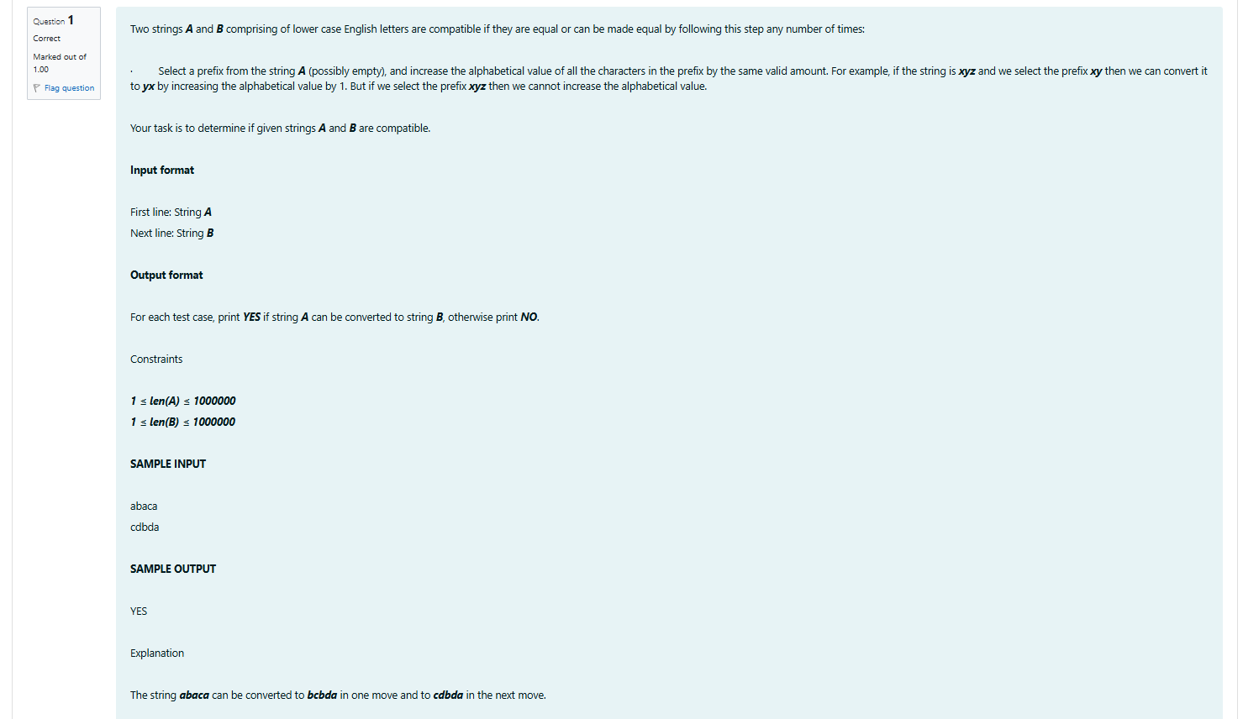

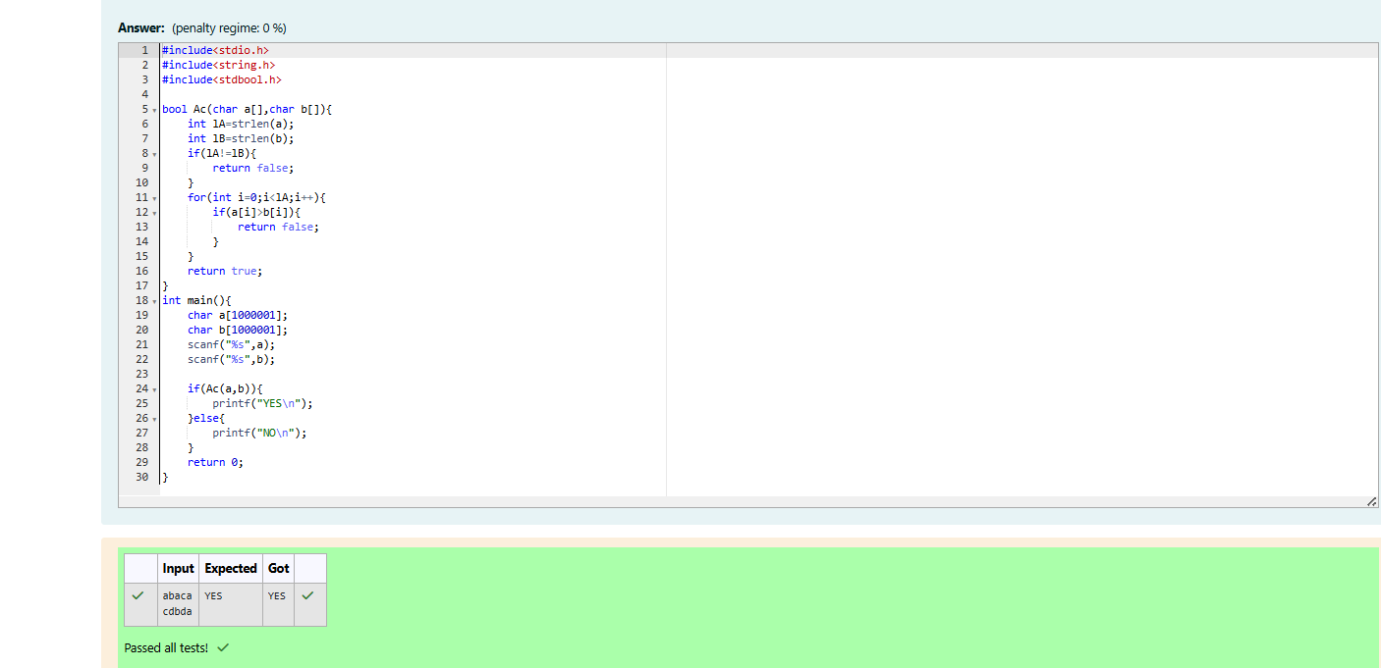

CODING

Reg no:241801289

Name:Tamilselvan.k

Q2

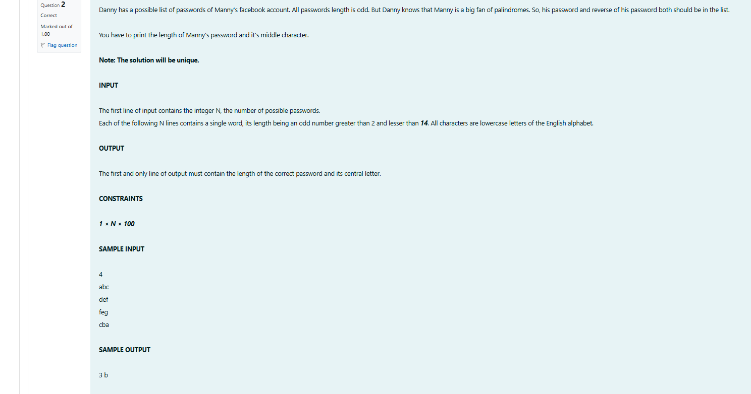

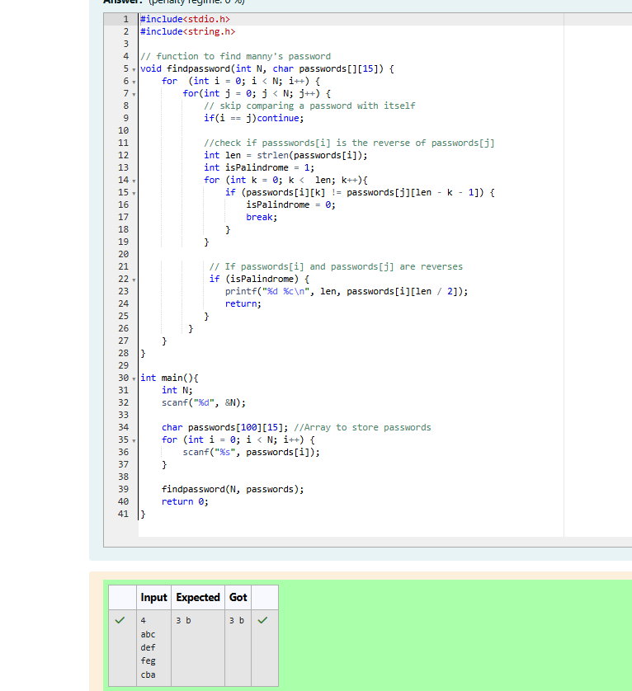

CODING

Reg no:241801289

Name:Tamilselvan.k

Q3

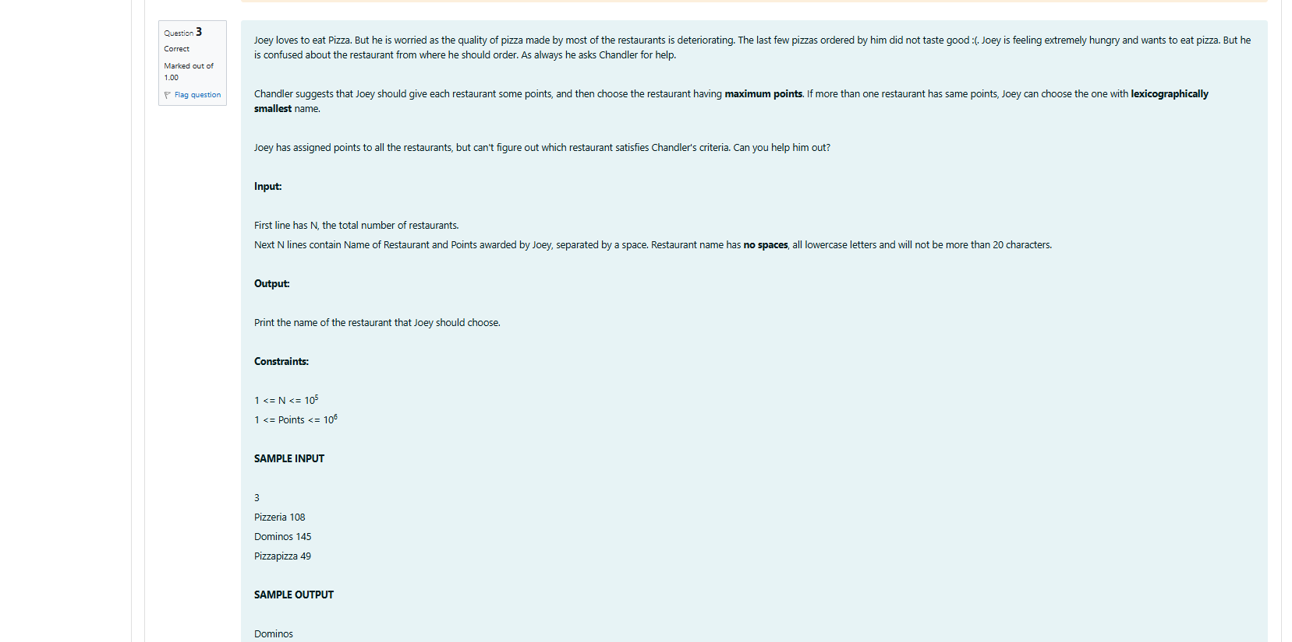

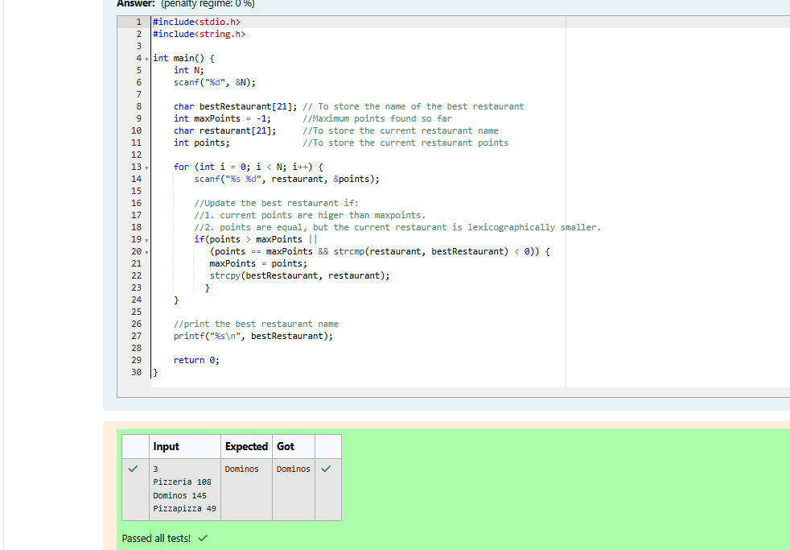

CODING

Reg no:241801289

Name:Tamilselvan.k

Q4

